Clerk’s report for August 2022

There have been a number of emails from Suffolk which can be shared with the parishioners:

- “Babergh and Mid Suffolk District Councils are hosting a ‘Be a Councillor’ event on Thursday 29th September from 16:00pm until 18:30pm in the King Edmund Chamber at Endeavour House.

Ahead of the 2023 elections, we are looking to attract a wide and diverse range of people to stand as candidates across both districts next May”

- Circular on key activities within Mid-Suffolk District Council

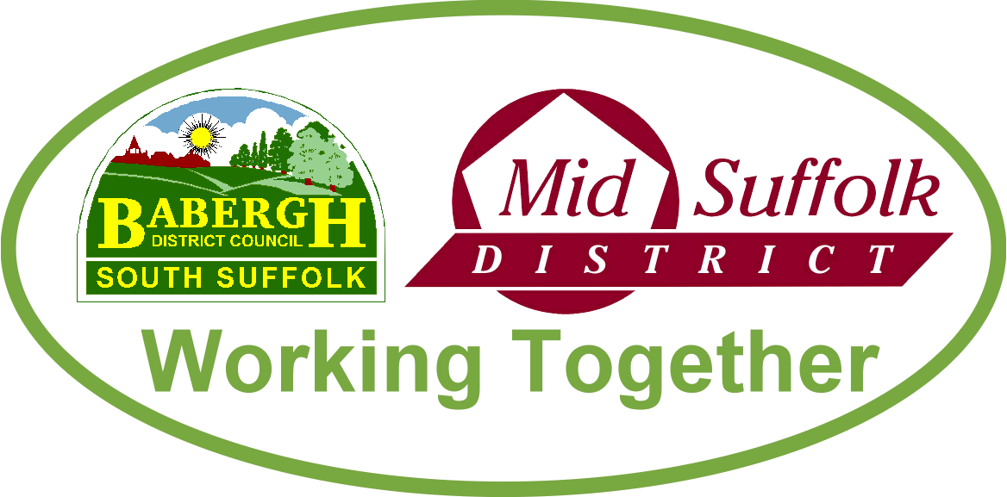

September 2022

How your council can help you with the cost of living
Support packages to combat the cost of living, energy bills and council tax are all available through Babergh and Mid Suffolk District Councils, with residents urged to check they are receiving the support they are entitled to. More information

Councils set to lead the way in transforming tree planting for generations
Tree coverage across Babergh and Mid Suffolk is set to increase to help tackle biodiversity loss and climate change, after a pioneering council-commissioned tree canopy survey identified key planting locations and significant benefits. More information

New parents again invited to apply for a free tree
Babergh and Mid Suffolk’s popular Tree for Life scheme, which offers a free tree for new parents, is open once again for 2022 applications. More information

Don’t lose your vote – residents across the districts urged to check their voter registration details
Babergh and Mid Suffolk District Councils have started the Annual Canvass of Electors and are asking residents to check the electoral registration details for everyone eligible to vote at their address. More information

Find out ‘What’s Next for Stowmarket’ at public exhibition
A new pop-up exhibition coming to Stowmarket from Thursday 22 September to Saturday 24 September at the town’s John Peel Centre will showcase a range of projects and proposals that will shape the future of the town. More information

…including Stowmarket wellbeing and leisure hub
Residents, community groups and sports clubs are being invited to have their say on the development of plans for new leisure, health and wellbeing facilities in Stowmarket. More information

Switch onto the Digital Skills Programme for businesses
Business owners in Babergh and Mid Suffolk can take advantage of free workshops to help boost their confidence online by accessing the Councils’ Digital Skills Programme. More information

Simple scheme to buy solar panels returns for Suffolk residents
Solar Together Suffolk, a group-buying scheme which has helped over 1,500 homes in Suffolk to install solar panels and batteries, is now open for new registrations. More information

Suffolk Waste Partnership backs national campaign to raise awareness of safe battery disposal
Suffolk Waste Partnership is backing a nationwide campaign urging people to safely dispose of old batteries in a bid to avoid starting fires in refuse vehicles and waste processing facilities. More information

Putting Suffolk on the big screen
Babergh and Mid Suffolk leaders have joined colleagues from across the county to agree steps to continue to attract filmmakers to the region – putting Suffolk on the big screen and bringing in millions to the local economy. More information

Councils awarded £60k for gum busting clean up
West Suffolk Council and Babergh and Mid Suffolk District Councils are among the first of 40 council areas to receive cash from chewing gum manufacturers to help remove gum from the street. More information

Event to explore NHS career opportunities
A careers event in Stowmarket last month helped showcase the vast range of career paths available within the NHS for local youngsters. More information

- Cost of living crisis:

How your council can help you with the cost of living

For immediate release: 15 August 2022
Support packages to combat the cost of living, energy bills and council tax are all available through Babergh and Mid Suffolk District Councils, with our staff here to direct residents to the help they are entitled to.

Many schemes and rebates have been announced in 2022 to ease the financial burden on people across the UK as well as in our districts. Babergh and Mid Suffolk District Councils are urging residents to check they are receiving the support they are entitled to, including the funds below.

To help with the rising cost of energy bills, the Council Tax Energy Rebate provides a £150 payment which is not repayable, to households in bands A-D. Payments have already been made to more than 66,000 households in these bands, with arrangements being made for the remaining recipients. The scheme has now been expanded and the discretionary scheme will offer up to £150 to those people not eligible for the main scheme but in need of financial help to cover the cost of energy bills.

The discretionary element of the Council Tax Energy Rebate is open to people in different council tax bands who may be paying rent and energy bills but are not liable for council tax such as those in a house of multiple occupation (HMO), those in receipt of Universal Credit or Housing Benefit, those in receipt of Council Tax Reduction, or other exceptions.

Applications for this funding close on 4 September 2022, so the council is encouraging anyone struggling to check if they are eligible and apply.

Residents can apply to pay less council tax through the Council Tax Reduction housing benefit. Using the councils’ online calculator, they can find out whether they would be entitled to a 95% reduction in their council tax bill.

There is also the Household Support Fund (HSF), a £170,000 pot split between both councils, which is available to help meet the cost of many household expenses. Those in financial hardship can get help paying for food and essential household goods, including school uniforms, equipment, and household energy bills.
Cllr John Ward, leader of Babergh District Council, said:
“We know how tight things are for people right now – and household budgets are set to be squeezed further over coming months. We are here to help our residents and communities and want to ensure people understand the range of support available and how to access it. Combating the cost of living is one of our top priorities, so I urge anyone who thinks they may be entitled to this help to check our website for more information.”
Cllr Suzie Morley, leader of Mid Suffolk District Council, said:
“The wellbeing of our communities and residents is of the utmost importance, which is why we have these schemes in place, with many of them being paid directly to households. The HSF and Council Tax Reduction are fantastic resources which let us reach those in our districts with support where other nationwide funds might not.
“Making sure everyone can afford to live and work in our districts is front of mind for the councils, and we are working to ensure we can tackle the cost of living both now and in the coming months and years.”
These steps are in addition to the national schemes already introduced and coming into effect this winter. The widest reaching of these is the £400 energy bills support payment; this replaced the previous £200 payment announced and will not have to be repaid. The payment will be split over six months and paid to all households with a domestic electricity meter, starting from October 2022. Those with pre-payment meters will have the money applied to their meter or paid via a voucher. Additionally, there is:
- A £650 cost of living payment. Paid directly into claimant bank accounts by DWP, it is split into two payments (paid in July and October) for households in receipt of universal credit, income-based jobseekers’ allowance, income-related employment and support allowance, income support, working tax credits, child tax credit or pension credit
- A £300 pensioner cost of living payment. All pensioner households will receive this as a top-up to their annual winter fuel payment in November/December 2022, and in addition to the payment above
- A £150 disability cost of living payment. This is a direct payment in September for those receiving disability living allowance, person independence payment, constant attendance allowance or war pension mobility supplement.

- Maintenance of grass verges. PCC has been approached by Hartleys Garden Services to offer professional commercial landscape service throughout Suffolk and Essex.
Hartleys are keen to tender for the contract, currently held by Top Garden Services.
- Interest has been expressed in the land currently used by Lucy Blake – applicant was advised to respond to the advert in JD.

